BALLYMAHON MUNICIPAL DISTRICT

Corporate Affairs,
Aras an Chontae,
LONGFOIRT.

18th June 2015.

To: Each Member of the Ballymahon Municipal District.

A Chomhairleoir,

You are requested to attend the Annual Meeting of the Ballymahon Municipal District to be held in Ballymahon Community Library, on Thursday, 25th June 2015 at 4.00 p.m. to transact business, as set out on the Agenda hereunder.

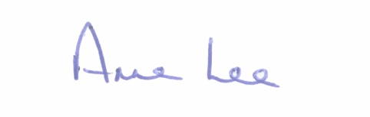
Mise le meas,

_______________
Anne Lee,
Meetings Administrator.

C L A R

1. Election of Cathaoirleach.

2. Election of Leas Cathaoirleach .

3. Fix date and time of Ballymahon Municipal District meetings.

